PICTURES OF JOINT INVESTIGATION VISIT TO OANDO ENERGY RESOURCES LIMITED FACILITY AT 6” NEMBE-SOUTH/OBAMA FLOWLINE, AT SABATORU, NEMBE LGA, BAYELSA STATE ON 23RD OCTOBER, 2024.
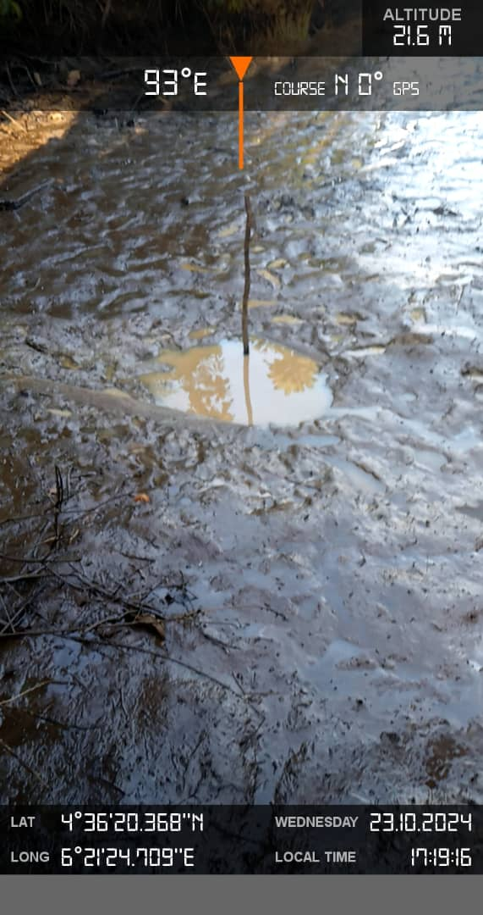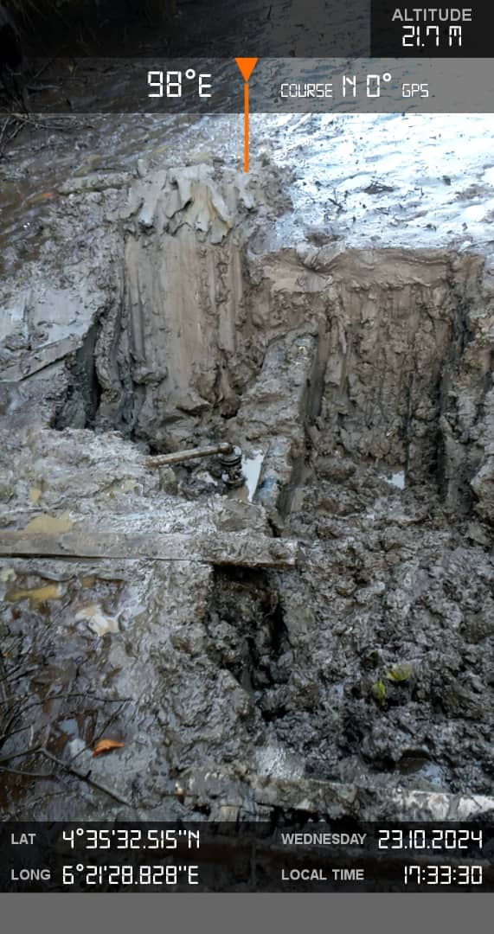
FIG. 1: THE STATE OF THE ENVIRONMENT. FIG. 2: 2” VALVE INSTALLED AT 12 O’ CLOCK POAITION

